The Population of Herefordshire 2025
Herefordshire Council Strategic Evidence and Insight Team
August 2026
Version 1.0

New population estimates for mid-2025

New mid-2025 population estimates show that Herefordshire's resident population is 192,500
Official estimates of the number of people living in local authorities are produced by the Office for National Statistics (ONS). These figures are used in calculations of shares of government funding, the planning of local services and a wide range of rates and measures of population well-being, including mortality rates and rates of ill health.
The mid-2025 estimate of 192,500 was 1,500 higher than the 191,000 reported previously for mid-2024. However, at the same time as publishing the mid-2025 figures, ONS has revised its estimates for mid-2022 to mid-2024, following improvements to international migration data.
These changes increased the estimated mid-2024 population by around 1,000 people, to 192,000. Compared with this revised estimate, the population grew by around 500 people (0.2%) between mid-2024 and mid-2025, the slowest annual increase since the year to mid-2020.
Table 1 compares the original and revised ONS Mid-Year Population Estimates for Herefordshire, mid-2021 to mid-2024
Mid-year | original estimate | Revised estimate | Change
2021 | 187,500 | 187,500 | n/a
2022 | 188,500 | 188,900 | 400
2023 | 190,000 | 190,900 | 900
2024 | 191,000 | 192,100 | 1,000
2025 | 192,500 | n/a | n/a
Population estimates are rounded to the nearest 100. Differences are calculated from unrounded estimates and then rounded to the nearest 100.
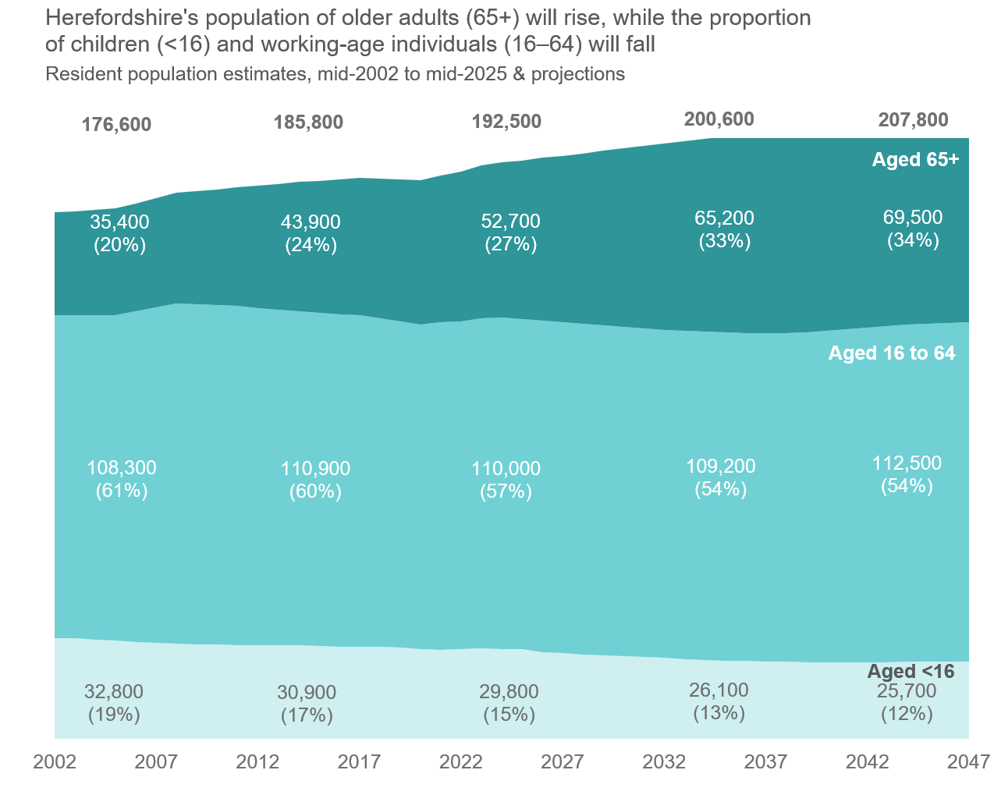
Data sources: Mid-2025 population estimates for the UK, Office for National Statistics. Published 29 July 2026. Subnational population projections for England: 2022-based, Office for National Statistics. Published 24 June 2025.

Population growth and drivers of change

Population growth continues to rely on people moving into Herefordshire
Population growth has relied on migration since the early 1990s, as deaths have consistently exceeded births. In 2024-25 there were around 1,400 births and 2,400 deaths, resulting in a natural decrease of almost 1,000 people. However, the overall population continued to grow because net migration more than offset the natural decrease.
The increases in the estimates of Herefordshire population for 2022 to 2024 were entirely due to upward revisions in international migration, with around 1,000 more migrants than originally estimated.
The slowdown in growth in the year to mid-2025 was largely driven by a marked fall in net international migration, from around 750 people in the year to mid-2024 to fewer than 100 in the year to mid-2025. This coincides with a national reduction in non-EU migration following recent changes to UK immigration policy that restricted eligibility for some work, study and dependant visas.

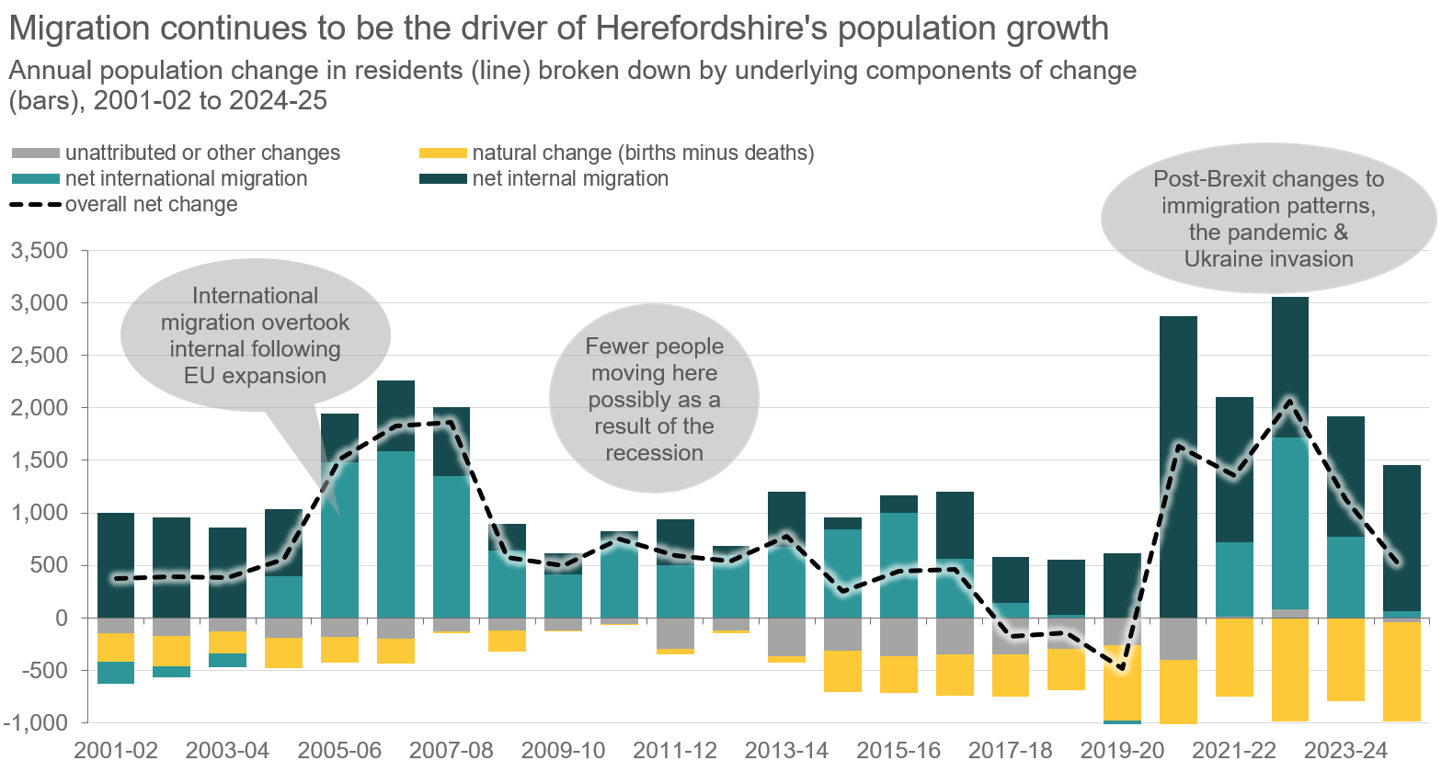

Data source: Mid-2025 resident population estimates, Office for National Statistics. Last accessed 29 July 2026.

Ageing population profile

Herefordshire’s age structure remains older than nationally, and numbers of older people will continue to grow
- In 2023, 27% of Herefordshire's population (52,700 people) were aged 65 and over, compared to 19% across England and Wales.
- Numbers in this age group grew by 20% between 2015 and 2025, a disproportionately higher rate compared to both nationally (16%) and the overall growth (4%).
- 7,200 residents are aged 85 and over, also reflecting a 21% increase from 2015.
- The old-age dependency ratio (OADR), which measures the number of people of pensionable age for every 1,000 working-age residents, was 443 in Herefordshire in 2025, compared with a median of 306 across local authorities in England and Wales. Herefordshire was among the 10% of local authorities with the highest levels of old-age dependency.

Numbers of children have fallen
- In 2025, 16% of the population (29,800 people) were aged under 16, compared to 18% in England and Wales.
- This represents a fall of 4% since 2015, contrasting with a 2% national increase.

Lower proportion of working age adults than nationally
- In 2025, 57% (110,000 people) were aged 16 to 64, compared to 63% nationally.
- While net migration added approximately 2,500 people to this age group in the past 5 years, the overall working age population remains 3,000 fewer than in 2008.
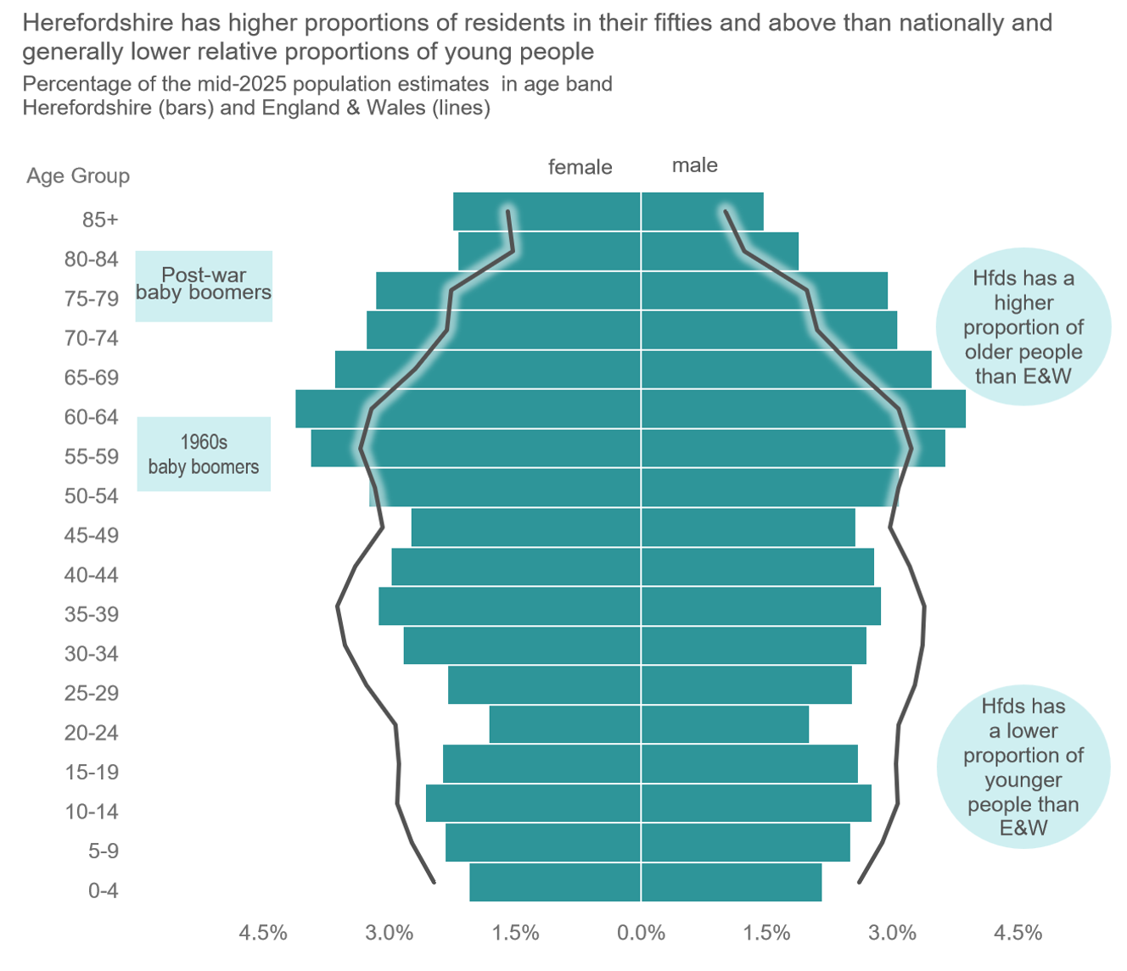
Data source: Mid-2025 resident population estimates, Office for National Statistics. Last accessed 29 July 2026.

